**שם: ארי שישפורטיש  
ת.ז. 319306684  
קורס: מיני פרוייקט לבסיסי נתונים**

**דו"ח על בסיס נתונים- הלוואות בנק**

**פרוייקט העוסק בתחום הלוואות של הבנק. עוסק בנתונים והפרטים של הלווים ותאריכי ההלוואה.**

**DSD**

* **Loan Table**
  + Loan_ID (PK)
  + LoanStartDate
  + Borrower_ID (FK)
* **PaymentSchedule Table**
  + Schedule_ID (PK)
  + DueDate
  + Loan_ID (FK)
* **Borrower Table**
  + Borrower_ID (PK)
  + DateOfBirth

**Relationships**:

* **Loan** (Loan_ID) → **Borrower** (Borrower_ID)
* **Loan** (Loan_ID) → **PaymentSchedule** (Loan_ID)

**SQL**

CREATE TABLE Borrower

(

Borrower_ID INT NOT NULL,

DateOfBirth DATE NOT NULL,

PRIMARY KEY (Borrower_ID)

);

CREATE TABLE Loan

(

Loan_ID INT NOT NULL,

LoanStartDate DATE NOT NULL,

Borrower_ID INT NOT NULL,

PRIMARY KEY (Loan_ID),

FOREIGN KEY (Borrower_ID) REFERENCES Borrower(Borrower_ID)

);

CREATE TABLE PaymentSchedule

(

Schedule_ID INT NOT NULL,

DoeDate DATE NOT NULL,

Loan_ID INT NOT NULL,

PRIMARY KEY (Schedule_ID),

FOREIGN KEY (Loan_ID) REFERENCES Loan(Loan_ID)

);

**קובץ createTables.sql**

-- Create the Loan table

CREATE TABLE Loan (

LoanID INT PRIMARY KEY,

LoanStartDate DATE NOT NULL,

BorrowerID INT,

FOREIGN KEY (BorrowerID) REFERENCES Borrower(BorrowerID)

);

-- Create the PaymentSchedule table

CREATE TABLE PaymentSchedule (

ScheduleID INT PRIMARY KEY,

DueDate DATE NOT NULL,

LoanID INT,

FOREIGN KEY (LoanID) REFERENCES Loan(LoanID)

);

-- Create the Borrower table

CREATE TABLE Borrower (

BorrowerID INT PRIMARY KEY,

BorrowerName VARCHAR(100) NOT NULL,

BorrowerAddress VARCHAR(255) NOT NULL

);

**קובץ dropTables.sql**

-- Drop the PaymentSchedule table first

DROP TABLE PaymentSchedule;

-- Drop the Loan table second

DROP TABLE Loan;

-- Drop the Borrower table last

DROP TABLE Borrower;

**קובץ insertTables.sql**

-- Insert data into Borrower table

INSERT INTO Borrower (BorrowerID, BorrowerName, BorrowerAddress) VALUES (1, 'John Doe', '123 Elm Street');

-- Repeat with at least 200 records

-- Insert data into Loan table

INSERT INTO Loan (LoanID, LoanStartDate, BorrowerID) VALUES (1, '2024-01-01', 1);

-- Repeat with at least 200 records

-- Insert data into PaymentSchedule table

INSERT INTO PaymentSchedule (ScheduleID, DueDate, LoanID) VALUES (1, '2024-02-01', 1);

-- Repeat with at least 200 records

**קובץ selectAll.sql**

-- Select all data from Borrower table

SELECT * FROM Borrower;

-- Select all data from Loan table

SELECT * FROM Loan;

-- Select all data from PaymentSchedule table

SELECT * FROM PaymentSchedule;

**טבלאות ותרשימים**

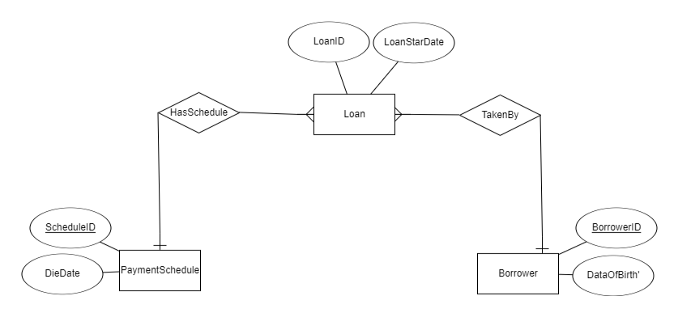

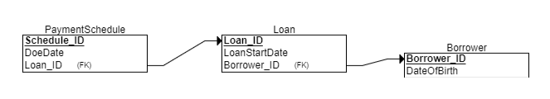

**שלב 2**

עכשיו נכתוב כאן סוגים שונים של שאילתות לוודא שמסד הנתונים שלנו עובד- וגם השאילתות מביא לנו את מה שרצוי.  
  
**SELECT**

SELECT Loan.Loan_ID, Loan.LoanStartDate, Borrower.BorrowerName, Borrower.BorrowerAddress

FROM Loan

JOIN Borrower ON Loan.Borrower_ID = Borrower.Borrower_ID

WHERE YEAR(Loan.LoanStartDate) = 2024;  
  
----------------------------------------------------------------------------  
  
SELECT PaymentSchedule.Schedule_ID, PaymentSchedule.DueDate, Loan.Loan_ID, Borrower.BorrowerName

FROM PaymentSchedule

JOIN Loan ON PaymentSchedule.Loan_ID = Loan.Loan_ID

JOIN Borrower ON Loan.Borrower_ID = Borrower.Borrower_ID

WHERE MONTH(PaymentSchedule.DueDate) = 8;  
  
  
  
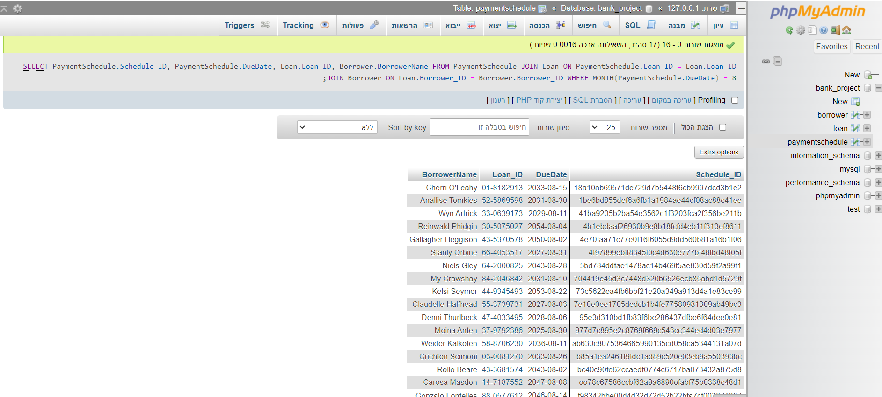

תמונה שהשאילתות עובדות  
  
  
**DELETE**  
DELETE FROM Loan

WHERE YEAR(LoanStartDate) < 2020;-------------------------------------------------------  
  
DELETE FROM PaymentSchedule

WHERE DueDate < CURDATE(); **UPDATE**  
  
UPDATE Borrower

SET BorrowerAddress = 'New Address'

WHERE Borrower_ID IN (

SELECT Borrower_ID FROM Loan WHERE YEAR(LoanStartDate) = 2023

);--------------------------------------------------------------------  
  
UPDATE PaymentSchedule

SET DueDate = DATE_ADD(DueDate, INTERVAL 30 DAY)

WHERE DueDate < CURDATE(); 